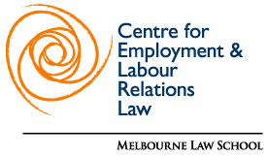
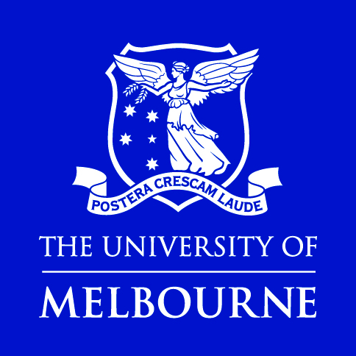

Berkeley Comparative Equality and Anti-Discrimination Law Study Group Annual Conference 2018

Call For Papers

The Berkeley Comparative Equality and Anti-Discrimination Law Study Group, hosted by Melbourne Law School at the University of Melbourne, and the Centre for Employment and Labour Relations Law, will hold its 2018 meeting in Melbourne on 11–12 June 2018.

Proposals are now being sought for workshop presentations. Papers on any topic relevant to equality and anti-discrimination law are welcome, and the committee proposes the following themes:
- Equality in a diverse world: tensions, conflicts and possibilities
- Intersectionality and equality law
- Enforcing anti-discrimination law: problems and successes
- Defining equality and discrimination in law

We anticipate inviting up to 30 scholars, lawyers and policy-makers to join us for two days of workshops, presentations and discussions.

All participants will need to pay for their own travel and accommodation to attend the conference: the conference organisers will organise discounted group rates at nearby hotels at a variety of prices. Meals during the conference will be funded by Melbourne Law School and the Centre for Employment and Labour Relations Law.

Limited subsidies to facilitate attendance at the conference are available for early career scholars, those without institutional funding and those from developing countries.

Melbourne Law School is located in the heart of Melbourne and convenient to Melbourne Airport: http://www.unimelb.edu.au/contact

Presentation proposals of 500 to 1000 words, or applications to participate as a discussant/panel chair, should be submitted no later than 31 October 2017. We encourage applicants to attach a brief CV to the proposal or application. If you wish to apply for a subsidy to attend the conference, please indicate this on your proposal, and provide a short (100 word) explanation of why you require the subsidy.
- Decisions will be announced by the end of November 2017.
- Papers and/or presentation materials should be ready for circulation to all participants no later than 11 May 2018.
- Proposals for presentations and/or papers will be reviewed by Professor Beth Gaze and Dr Alysia Blackham, Melbourne Law School and Professor David Oppenheimer, Berkeley Law.

Please send inquiries and presentation and/or paper proposals or applications to participate as a respondent to doppenheimer@law.berkeley.edu

