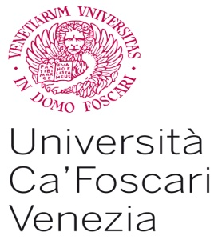  Department of Economics  Master Lavoro  Centre for Legal Studies  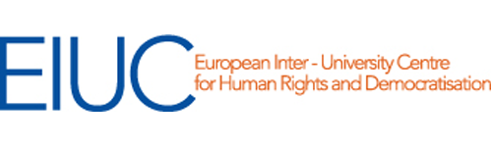 | 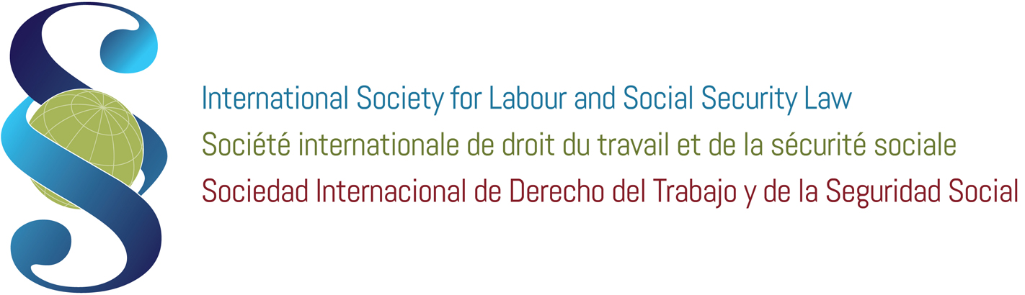
3rd International Seminar on International and Comparative Labour Law
Sustainable Development, Global Trade and Social Rights
19 June 2016 – 25 June 2016
Venice Ca’ Foscari University

Presentation of the Seminar
Sustainable Development is an interdisciplinary concept, which regards the environment, the economy and the social sphere. While relations between sustainability and environmental law have long been investigated, the "social pillar" of sustainability has yet to be adequately studied and developed by scholars of labor law. Sustainability concerns in fact, primarily, the “human and social capital” of any economic organization and its preservation over time. The social pillar needs then to be considered, analysed and studied, as it is more and more important in the Global Trade context, where Social Rights need to be supported and promoted, at national and international level, by all the stakeholders (employers, states, employees, consumers, trade unions, citizens, institutions, Ngos, communities and organizations).
This updated issue has been recently re-launched for example on the debate due to the recent USA trade agreement: the TTIP, Transatlantic Trade and Investment Partnership (with the EU) from the one side and the TPP, Trans-Pacific Partnership (with Brunei, Chile, New Zealand, Singapore, Australia, Canada, Japan, Malaysia, Mexico, Peru, United States and Vietnam) from the other side. In which way these agreements combine the promotion of economic reasons and social issues? Are they following the example of the other international trade agreement (ASEAN, MERCOSUR, NAFTA, etc…) or could be they considered as “a new era agreements”?
Scholars, both economists and jurists, needs to underlines this new interest in the link between international trade and social rights, which emerges not only in trade agreements context but also thanks to the new generation social clause (as for example in the new EU GSP), the Horizontal Social Clause of Article 9 TFEU, the new relationship between investments and sustainable development, the social rights respects as a component of an economic and social growth model in line with the ILO Agenda of Decent Work, the ISDS (Investor-State Dispute Settlement) Clause, etc. These are all examples of the promotion of the so called social Sustainability.
The interdisciplinary process of analysis that we propose to deepen during the Seminar, also thanks to the call for papers of the Young Scholars' Section ISLSSL, looks at Sustainability as a new scientific paradigm of Labor Law, providing a new legitimacy to social rights today increasingly questioned by the prevalence of a purely economic rationality, in this context of trade liberalization moved by globalisation. The ISLSSL Venice Seminar is aimed at analysing the most updated aspects of this linkage between social rights and international trade with an intensive and highly interactive week program that includes lectures, briefing by experts, working groups and case analyses on those topics. The seminar is aimed at PhD students, research fellows, academics and experts in the area of Labour Law, Sustainability, Economics, Trade and International Law.

Program

June 19, Sunday
Participants arrival and welcome drink. Establishment of working groups.

June 20, Monday

Morning, 9.30 – 1 am
Welcoming regards
Prof. M. Bugliesi – Venice Ca’ Foscari University Magnificent Rector
Prof. M. Billio – Venice Ca’ Foscari University, Economics Department Chair
Dott. L. Brugnaro – Mayor of Venice
Prof. T. Treu – ISLSSL President
Prof. M. Ricci – AIDLASS (Italian Society for Labour Law and Social Security Law) President
Prof. G. Casale – ISLSSL Secretary General, International Training Centre of the ILO Director and Venice Ca’ Foscari University Visiting Professor

Introduction to the Seminar
Prof. A. Perulli – Venice Ca’ Foscari University

Sustainable Development and International Trade

Prof. C. Giupponi – Venice Ca’ Foscari University
- Sustainable Development, Economic Theory and Social Rights: why we need a linkage

Prof. A. Lyon-Caen – Université Paris Ouest Nanterre La Défense, École des Hautes Études en Sciences Sociales (EHESS)
- The Social Clause: issues, concepts, origins and concerns. Theoretical assumptions

Prof. J. Kenner – University of Nottingham
- Sustainable Development and Labour Law: an European perspective

Lunch

Afternoon, 2.30 – 6.30 pm:
Working groups and discussion

June 21, Tuesday

Morning, 9.30 – 1 am

International Trade Agreements: the linkage between trade and social rights.

Prof. A. Goldin – University of Buenos Aires
- The MERCOSUR (Southern Common Market): Argentina, Brazil, Paraguay, Uruguay and Venezuela

Prof. J. Bellace – University of Pennsylvania
- Bilateral Free Trade Agreements (FTAs), the NAFTA (North American Free Trade Agreement) and the TPP (Trans-Pacific Partnership)

Prof. T. Araki – University of Tokyo
- The ASEAN (Association of Southeast Asian Nations) Agreement

Prof. M. Faioli – University Tor Vergata of Rome
- The TTIP (Transatlantic Trade and Investment Partnership) Agreement

Lunch

Afternoon, 2.30 – 6.30 pm:
Working groups and discussion

June 22, Wednesday

Morning, 9.30 – 1 am

The European Union internal and external action in the international trade relationships context.

Prof. A. Perulli – Venice Ca’ Foscari University
- Fundamental Social Rights in the Era of Globalization: the EU's strategy to promote respect for social rights in its external actions

Prof. T. Treu – ISLSSL President
- Weak and strong examples of Social Clause as a concrete example of linkage between the economic and the social dimension of trade

Prof. S. Giubboni – University of Perugia
- The Social Clause with reference to the internal dimension of the European Union market

Prof. M. Weiss – University of Frankfurt
- The EU Generalised Scheme of Preferences and the Special Incentive Arrangement for Sustainable Development and Good Governance ("GSP+")

Lunch

Afternoon, 2.30 – 6.30 pm:
Working groups and discussion

June 23, Thursday

Morning, 9.30 – 1 am

Investments, IMF, ISDS (Investor-State Dispute Settlement) Clauses and the Arbitral Procedures to resolve a conflict
Prof. S. Leader – University of Essex
- Social rights promotions and new strategies for global investments: the role of the Word Bank and of the International Monetary Fund

Prof. G. Casale – ISLSSL Secretary General, International Training Centre of the ILO Director and Venice Ca’ Foscari University Visiting Professor
- An overview on the ILO tools in the Organisation social rights promotion’s activity

Prof. G. Corò – Venice Ca’ Foscari University
- Multinational Investments and Labour Market

Lunch

Afternoon, 2.30 – 6.30 pm:
Working groups and discussion

June 24, Friday

Morning, 9.30 – 1 am

Young Scholars’ Section ISLSSL Papers presentation
Prof. S. Bellomo – University of Perugia

Lunch

Afternoon, 2.30 – 6.30 pm:
Working groups and discussion

June 25, Saturday

Morning, 9.30 – 1 am

In memory of Prof. Bob Hepple
Book Presentation Laws against strikes. The South African Experience in an international and Comparative Perspective (ed. by Hepple B., Le Roux R., Sciarra S., Franco Angeli, 2015)
Prof. S. Sciarra – Judge of of the Constitutional Court of Italy
Prof. G. Casale – ISLSSL Secretary General, International Training Centre of the ILO Director and Venice Ca’ Foscari University Visiting Professor
Prof. M. Weiss – University of Frankfurt
Prof. V. Speziale – University of Chieti - Pescara

Final reports presentation and discussion
Prof. A. Perulli – Venice Ca’ Foscari University
Prof. V. Brino – Venice Ca’ Foscari University
Prof. G. Zilio-Grandi – Venice Ca’ Foscari University

Seminar conclusion by 1 am.

Notes

Lectures and working groups will be in English.

Registration period: February 1 – May 30, 2016.

Scientific Direction and Coordination: Prof. A. Perulli.

International Scientific Committee: A. Goldin, T. Treu, G. Casale, A. Lyon-Caen, F. Valdes Dal-Re, L. Compa, S. Sciarra, M. Weiss, J-M. Servais, A. Brugiavini.

For any information, please write an email to islsslseminar@gmail.com

