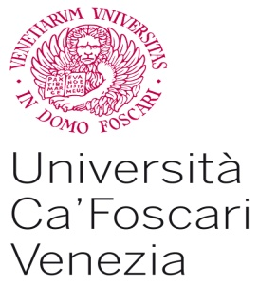  Dipartimento di Economia  Master Lavoro  Centro Studi Giuridici | 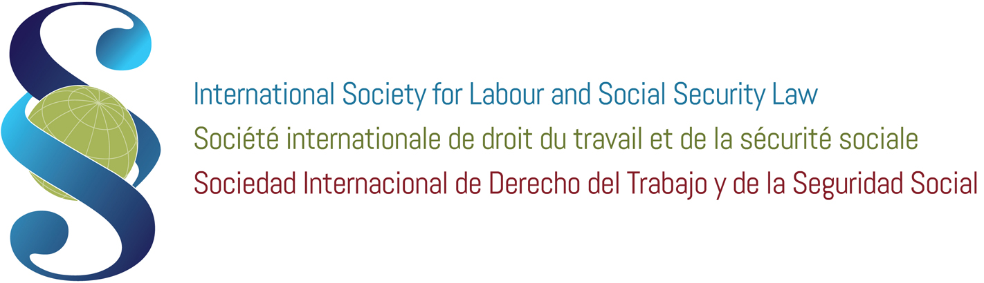  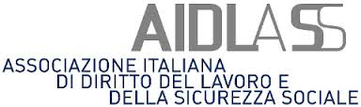

2nd International Seminar on International and Comparative Labour Law
Enterprise Transformation and Social Rights
Venice, 30 June – 9 July 2015

June 29th, Monday
Participants arrival.

June 30th, Tuesday
Morning:
Welcoming of participants
Prof. M. Bugliesi – Venice Ca’ Foscari University Magnificent Rector
Prof. M. Billio – Venice Ca’ Foscari University, Economics Department Chair
Prof. A. Perulli – Venice Ca’ Foscari University
Prof. A. Goldin – ISLSSL President
Prof. G. Casale – ISLSSL Secretary General, Venice Ca’ Foscari University Visiting Professor
AIDLASS (Italian Society for Labour Law and Social Security Law) President

Enterprise organization, the boundaries of the firms and the concept of employer: economics, labour and commercial law analysis.
Speakers:
O. D. HART (Harvard University)
A. LYON-CAEN (University of Paris Ouest Nanterre La Defense)
F. DENOZZA (University of Milan)

Afternoon:
Working groups and discussion

July 1st, Wednesday
Morning:
Enterprise transformations, externalization processes and productive decentralization.
Speakers:
J.-M. SERVAIS (Former Director of International Labour Office (ILO), Honorary President of ISLSSL)
A. GOLDIN (University of Buenos Aires)
R. DEL PUNTA (University of Florence)
G. CORÒ (Venice Ca’ Foscari University)

Afternoon:
Working groups and discussion

July 2nd, Thursday
Morning:
Enterprise-network and enterprise-groups: trends and national/international experiences.
Speakers:
S. LEADER (University of Essex)
O. RAZZOLINI (University of Genoa)
V. SPEZIALE (University G. D’Annunzio, Chieti-Pescara)

Afternoon:
Working groups and discussion

July 3rd, Friday
Morning:
Decentralization and internationalisation in collective bargaining process
Speakers:
S. SCIARRA (Judge of the Constitutional Court of Italy, University of Florence)
F. VALDES DAL-RE (Complutense University of Madrid, Judge of the Constitutional Court of Spain)
G. CASALE (ILO and Venice Ca’ Foscari University)
T. ARAKI (University of Tokyo)

Afternoon:
Working groups and discussion

July 6th, Monday
Morning:
The enterprise in the EU law.
1st session: Enterprises and the Courts role.
Speakers:
F. BENOIT-ROHMER (University of Strasbourg, EIUC (European Inter-University Center for Human Rights and Democratisation) Secretary General, TBC)
J. KENNER (University of Nottingham)

2ND session: Workers participation in the enterprise: information and consultation rights, codetermination dynamics and firms welfare
Speakers:
T. TREU (University Cattolica of Milan)
M. WEISS (Goethe University of Frankfurt/Main)
A. BRUGIAVINI (Venice Ca’ Foscari University)

Afternoon:
Working groups and discussion

July 7th, Tuesday
Morning:
The “constitutionalisation” of the Firm. Multinationals regulation in the global context between hard and soft law.
Speakers:
T. SACHS (University of Paris Ouest Nanterre La Defense)
S. VERNAC (University of Paris Ouest Nanterre La Defense)
V. BRINO (Venice Ca’ Foscari University)

Afternoon:
Working groups and discussion

July 8th, Wednesday
Working groups (all the day)

July 9th, Thursday
Morning:
Final reports and discussion
Seminar conclusion by 1 am.

Notes
Lectures and working groups will be in English.

Registration period: February 1 – May 30, 2015.

Deadline to pay: 1 June 2015.
Registration fees, which include accommodation in a University Residence, in a single room with private bathroom, (in 29 June, out 9 July), breakfast, meals and administration is 1000 Euros (+ IVA 22%, 1220 Euros).
Direction and Coordination: Prof. A. Perulli.

International Scientific Committee: A. Goldin, T. Treu, G. Casale, A. Lyon-Caen, F. Valdes Dal-Re, L. Compa, S. Sciarra, M. Weiss, J-M. Servais, A. Brugiavini

Further detailed information and registration forms are available on : http://islssl.org/category/meetings-events/ or please write an email to dirittodellavoro@unive.it.

Please note that:
- the ISLSSL offers six scholarships of 1220 Euros each (only candidates coming from different countries from Italy are eligible)
- the AIDLASS starts the selection process for the award of 1 scholarships (1,220 euros each) for Italian candidates.

Each scholarship includes accommodation (in 29 June, out 9 July 2015, in a University Residence, in a single room with private bathroom), breakfast, meals and administration.

Application for ISLSSL scholarship: February 1 - March 30, 2015.
Application for AIDLASS scholarship: April 15 – May 15, 2015.

For any information, please write an email to dirittodellavoro@unive.it

With the contribution of :

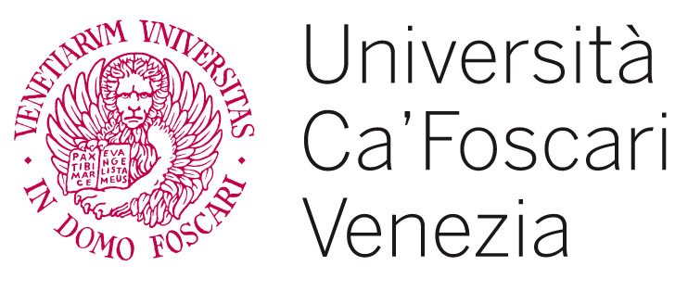
Dipartimento di Economia

