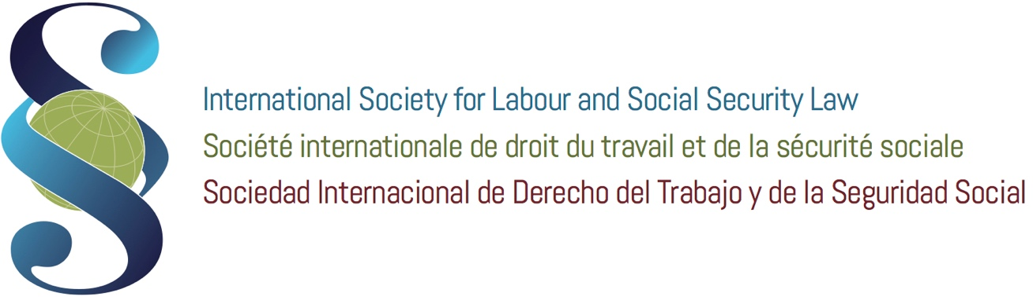

6th International Seminar on International and Comparative Labour Law

ISLSSL YOUNG LEGAL SCHOLARS’ SECTION
CALL FOR PAPER
TO THE NATIONAL ASSOCIATIONS OF
THE INTERNATIONAL SOCIETY FOR LABOUR AND SOCIAL SECURITY LAW

9th January 2019

Dear colleagues,

the 6th International Seminar on International and Comparative Labour Law will take place in Venice, at Cà Foscari University on 27-31 May 2019.

The 2019 edition of the Seminar will be dedicated to the issue of “The Future of Work. Labour Law and Industrial Relations in the Digital Era”.

All Seminar’s participants are invited to take an active part in the discussion from an interdisciplinary perspective.

In particular, on Friday, 31st May a session will be dedicated to the presentation and discussion of the papers presented by the Young Legal Scholars of the ISLSSL.

This call for paper is open also to all Young Scholars who would like to take part in the International Seminar.

Of course, the interested scholars can also submit additional perspectives of analysis, but always linked to the general theme of the Seminar.
Researchers and Young Scholars from countries around the world are invited to submit original papers with new and innovative results on scientific, technical and practical experience.

As is customary for the ISLSSL, papers should be quantitative and rigorous.
A (non-exclusive) list of potential conference topics is:

- The platform work. The first question concerns the nature of these working relationships, their identification, the perimeter in which they move, questioning the classic labor law paradigm based on the exchange between a subordinate work and retribution, in the context of a working community and within a circumscribed and identifiable undertaking. The development of the collaborative economy, but even more the digitalisation of production, contribute to the emergence of new forms of activity, on the border between subordination and autonomy. Are these new forms of subordinate work? or new types of self-employment? Or are these hybrid forms of work referable to the "third categories" that exist in some legal systems? The solutions offered by the jurisprudence are very heterogeneous, and it is difficult to establish ex ante the legal nature of these relationships, given also the heterogeneity of the models of organization of production and work through platforms. For its part, the legislator does not seem ready to provide ad hoc protections dedicated to these workers, as for example the French legislator. Often deprived of the protection of subordinate employment, these "operators" of the digital market do not enjoy the advantages of true independence on the market, ending up adding the disadvantages of both statuses. What are the possible solutions?
- The 4.0 company and the work. The second theme concerns the impact of digitization on the forms of organization of the company, allowing working methods free from the rigid respect of the "place" and "time" of work as regulated by the classical model of the Fordist enterprise. Smart working, "agile work", forms of work subtracted from the hierarchy and the exercise of unilateral powers open new perspectives for a more "democratic" subordination (as in the case of "agile work" in Italy, which refers to the individual pact between worker and employer the discipline of how to exercise entrepreneurial powers of management and control)? Or, on the contrary, pose new challenges to the regulation and protection of workers, exposed to new forms of exploitation and control, hence the need to think about new rights (such as disconnection)? Firm 4.0 therefore requires an analysis aimed at verifying, in concrete terms, the new set of interests mediated by the employment contract. In particular, a) the interest in defining the forms of exercise of employers' powers in view of the better reconciliation of life and work times and therefore as a function of an unprecedented co-responsibility of the subordinate worker in defining the procedures for exercising the powers of the employer; b) the interest in the contractual definition of the ways in which the entrepreneurial prerogatives are implemented when the worker realizes the "disintermediate" performance from the standard work environment, in a different form from the normal "insertion" in the business organization.
- The impact of digitization on collective labor relations. The consequences of digitization on industrial relations is potentially devastating. The breakdown of the working community, the disintermediation made possible by forms of organization of the work of the company 4.0, and even more the "loneliness" of the worker of the platforms, often deprived of collective rights because qualified as non-subordinate, open a very gloomy scenario for industrial relations in the digital enterprise era. Yet new forms of collective representation of the interests of these workers are emerging. These are new forms of collectivism, which exploit technological means, social media, new forms of union aggregation of atypical and autonomous workers .... Do these new structures of collective representation of interests follow in the footsteps of the old worker trade unionism? or are new logics emerging, outside the traditional trade union channels? what are the most significant experiences in this sector? how are traditional trade unions moving towards the diffusion of digital work?

Selected papers will be presented and discussed in thematic sessions, circulated during the meeting, and also posted on the meeting website.
The publication of a book containing the selected papers, published by Kluwer, is also planned.

INFO FOR YOUNG SCHOLARS FOR SUBMISSION OF THE ABSTRACT

Full papers or long abstracts (minimum 1000 words) in pdf format should be submitted online no later than April 1st, 2019.
Please note that paper selection has become increasingly competitive in recent years. Submissions that fully describe a complete analysis are generally more likely to be accepted than long abstracts. In particular, when submitting a long abstract, please ensure that the study and results are sufficiently described to allow comparison with full paper submissions. Each person can present only one selected paper, although multiple submissions and co-authorship are allowed.
The papers and the abstract have to be sent to the following addresses: stefanobellomo@mmba.it, adaper@unive.it and islsslseminar@gmail.com .

The abstract’s paper will be examined by the Seminar’s organizers and if accepted the full paper (no more than 30.000 characters, including spaces, footnotes and appendix) has to be presented at the Session of May 31st 2019.

Participation to the seminar:
The Young Scholars have the option to choose to attend the whole Seminar or only the session of May 31st.

1) PARTICIPATION IN THE WHOLE SEMINAR:

If the Young Scholars want to attend the whole Seminar, they could ask to their National Association to submit their candidature for the award of a scholarship: ISLSSL offers six scholarships (1,220 euros each) which includes accommodation (in May 26th, out June 1st), in a university residence, in a single room with private bathroom, breakfast, meals and administration expenses. Please refer to the complete program and conditions of participation at the web address http://islssl.org/4th-seminar-on-international-and-comparative-labour-law-final-program/.
Please notice that all Scholarship winners must write a paper for the Young Scholars’ Session of the Seminar.
2) PARTICIPATION ONLY IN THE SESSION of May 31st.

Young Scholars could attend only the Session of Friday, 31st of May where the paper should be presented. In this case the Seminar organizers will provide for the Young Scholars who will participate only in the session of 31 May, accommodation in Colleges or residences which are connected to the Ca’ Foscari University for the nights of 30 and 31 May (in 30 May, out 1 June).

For any further information please contact Prof. Stefano Bellomo (stefanobellomo@mmba.it), Prof. Adalberto Perulli (adaper@unive.it) or write an email to islsslseminar@gmail.com.

Best regards.
Prof. Adalberto Perulli
Prof. Stefano Bellomo

